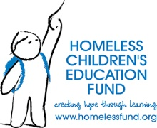

FOR IMMEDIATE RELEASE Media Contact
June 15, 2026 Kristin Wenger
media@homelessfund.org
412-523-9362

Homeless Children’s Education Fund Launches Student-Authored Book
Echoes of Brilliance
Student writings and artwork take center stage at The I AM Gala presented by Dollar Bank
benefiting Pittsburgh's homeless youth
PITTSBURGH, Pa — Homeless Children’s Education Fund (HCEF) brought together community leaders, advocates, educators and supporters at The Westin Pittsburgh on June 13 for The I AM Gala presented by Dollar Bank, an immersive evening centered on student voice, dignity and the power of education to transform lives.
The event, which raised a record-breaking $426,500 to expand programming and services, served as both a celebration and a call to action. It highlighted the resilience of the more than 1,100 students HCEF serves who are experiencing homelessness while generating critical support to ensure educational stability, opportunity and long-term success.
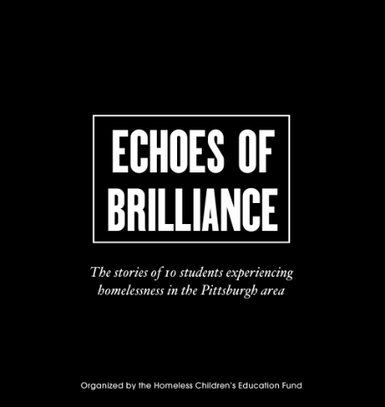
A defining moment of the evening was the official launch of Echoes of Brilliance, a student-authored book featuring original writings and artwork from students served by HCEF. The collection offers an unfiltered window into the lived experiences of young people navigating housing insecurity while striving to remain engaged in school and build hopeful futures.
Throughout the evening, students served as “Brilliance Ambassadors,” sharing their stories, introducing speakers and engaging directly with guests, reinforcing HCEF’s belief that students are defined not by circumstance, but by their strength, creativity and potential.
“This book is more than pages and words, it represents presence, truth and courage,” said AJ Jefferson, President and CEO. “Echoes of Brilliance reflects what we see every day in our students: brilliance that refuses to dim, even in the most difficult circumstances. When we listen to them, invest in them and stand with them, we are not just supporting education, we are protecting futures.”
The evening also featured recognition of presenting sponsor Dollar Bank; platinum sponsors Michael and Steffanie Jasper; titanium sponsors Duolingo, PPG Foundation and UPMC Health Plan and Duquesne Light Company and its President and CEO, Kevin Walker, whose support helped make the event’s immersive experience possible.
The program included the inaugural President’s Award for Transformational Impact, presented to Blayre Holmes Davis, senior director of community relations for the Pittsburgh Steelers, in recognition of her sustained partnership and investment in expanding opportunities for HCEF students through experiential learning and community connection.
Additionally, the Dr. Joseph Lagana Champions for Children Award was presented to the Pittsburgh Indian Community and Friends in recognition of their collective commitment to service, partnership, and support for children and families across the region. To date, the group has contributed more than $150,000 to the Homeless Children's Education Fund and announced an additional $50,000 gift during the gala.
A live auction of signed editions of Echoes of Brilliance further supported HCEF’s mission, with proceeds benefiting programs that provide educational advocacy, school-based support, emergency assistance and enrichment opportunities for students experiencing homelessness.
Funds raised during the evening will help sustain HCEF’s Childhood-to-Career Continuum, ensuring students have the resources and relationships needed to stay connected to school and pursue long-term success. HCEF's impact is evident in its outcomes, with 82% of participating students making progress toward academic proficiency and 90% graduating from high school.
The evening concluded with a celebration of community and a call for continued support through monthly giving and ongoing engagement with HCEF’s mission.
For more information about the Homeless Children’s Education Fund or to support its programs, visit www.homelessfund.org.
About Homeless Children’s Education Fund
The Homeless Children’s Education Fund (HCEF) is dedicated to ensuring that children and youth experiencing homelessness have access to the educational opportunities, support, and stability they need to succeed. Through advocacy, funding, and partnerships, HCEF works to break barriers and empower students facing housing insecurity.

